**Navigation and Movement Preferences using Low-Cost VR Headsets**

**Mustafa Khalif Ahmed, Khang H II Le, Trieu Le, Vamshi Nizampatnam, Derek Martin Wicoff**

University of Washington, Tacoma, Washington

**ABSTRACT**

Player movement is required for virtual reality to enhance user experience through various methods. There are many ways to move around in VR, requiring users to use either rotating headset movements or button inputs. The first action method to be tested will be teleportation, a significant aspect of our game. The second movement method participants can use vertical head-tilting.

Furthermore, the paper seeks to determine whether there is a difference in ease of use between different movement methods. Investigating the user's experience and once the participants have completed both movement methods in the VR game, researchers can then assess the user experience. The survey results will discuss the most effective and accessible movement methods for further improvement. In short, the results of the study seem promising. To gauge user experiences across both movement methods, the following results were gathered after completing the investigation. Both locomotion methods had advantages and disadvantages, according to the survey. In this paper, the writers will discuss in depth the results and limitations of our work.

**INTRODUCTION**

Virtual reality has multiple methods of player movement. Movement in VR can involve many various techniques and approaches, requiring users to use one or a combination of rotational headset movements and/or button input. The aim of this paper is to determine what movement methods are the most viable as well as the most enjoyable for user experience in low-price VR headsets. User experience is an important aspect of the VR experience, if controlling the player is difficult to manage or severely disorients the users, in the case of some teleportation methods, then the VR experience will suffer. This paper further aims to answer the question of, is there a difference between the various movement methods in relation to ease of use?

In order to make the best VR experiences, the following research will be conducted to try to find what movement methods most players will enjoy as well as which movement methods are most effective. Participants’ preferences for various methods of moving the player around the map will be tested and the user experience will be measured with a survey given to participants where they will rate the ease of use and enjoyment of using different methods of movement. The results of the survey reflecting each user’s preferences will also be analyzed with regard to the tasks the users are required to perform, as well as the size and shape of the environment they must traverse in order to postulate what the most optimal movement method may be.

**RELATED WORK**

Users of VR can exhibit different approaches and overall strategies to movement depending on the environment in which the users are navigating through. The research paper by Logan D. Clark and Sara L. Riggs [3] goes in-depth on how a user’s movement strategy can influence interaction behaviors within VR. Their contributions include a study conducted within the paper, aiming to evaluate the effects of movement behavior using kinematic movement trajectory analysis. Participants within the study moved to targets positioned at varying depths in either one of two directions along each respective axes in a VR environment. Then “trajectory profiles” were obtained and evaluated to identify kinematic milestones.

Their findings show users exhibiting task completion times throughout all conditions that are similar but show a huge variation in movement strategies to move to targets in different locations. This implies that users will adapt and change their movement behaviors in order to optimize movement performances. The limits of the study involve the inability to incorporate a “variable fore period” between the start of every trial. Another limitation is the inability to manipulate what the targets look like. The difference lies in the implementation of objects to interact with that rely more on intuition and choice rather than being told to move towards a set target. This will not impact the movement controls themselves but will impact how a user will approach certain objects based on their perception of the environment built for the user.

**User-generated Controls**

The findings of the paper by Woojoo Kim and Shuping Xiong [4] suggest that user-generated controls provide a better user experience with better movement options in VR. Many papers are written about letting users select their input methods as well as creating user-defined methods. Our work will not be using an expensive headset to track movement. The other paper uses many motions that could be used as ideas for our project. If users have the ability to record movements this would allow users to create user-defined movements that they can use for mode switching.

The limits of the in-place locomotion study include using a more expensive VR setup, as well as human gait being different with each person, and the motions used were often hard to detect. The motions they would use will be easily replicable without making the game uncontrollable. There should be a focus on having good and well-implemented controls.

**Locomotion Methods**

The relation of the paper titled “Effects of Virtual Reality Locomotion Techniques on Distance Estimations” [2] to our proposed work is about the artificial locomotion and teleportation technique. The teleportation locomotion method allows the application of counting strategies that induce fewer cognitive demands than counting strategies applied during artificial locomotion. The article examines how VR motion impacts spatial perception in a virtual reality environment and shows how different movements are associated with different levels of spatial perception. Researchers found that people who use physical movement more in space have a greater awareness of space than those who use teleportation since teleportation causes skewed data because it lacks motion cues.

Study experiments in this article utilize the spotting a red dot technique placed at a random position that cannot be seen from the starting position in order to estimate the travel distance from the starting position and the importance of locomotion methods to minimize the length of the scene and to reduce the risk of VR sickness. The limited spatial perception in the use of VR is a limitation because VR is not widely used.

Navigation is required when shifting a user's viewpoint, inappropriate locomotion can degrade task performance. The relation of the paper “Evaluation of locomotion methods in virtual reality navigation environments: An involuntary position shift and task performance” [6] to our proposed work is about Teleportation. This study was conducted with a small number of participants and the navigation task adopted was easy. In the study, teleportation took the shortest task completion time, but its error time ratio was the largest. This finding is expected to contribute to the establishment of safety precautions for the VR experience.

Locomotion is, if not the essential part of any VR application, and knowing these techniques is critical to developing a human-centered interaction application. This research paper/journal article [1] from Heni Cherni and her colleagues analyzed plenty of locomotion methods they noticed in a paper review. The whole goal is to see how each locomotion method can enhance user experience and the best ways one can be better equipped to create these movements in VR. This research study put locomotions into different categories, from user body-centered to external surroundings.

The study concluded that each locomotion method had its advantages and drawbacks. It is understandable that our proposed work isn't going to be this advanced due to the limitation of the google cardboard VR, however, our goal is to implement some of these methods in our VR application to the best of our ability. In the study itself, they were limited in terms of confirming the usability, this will strengthen their study on the locomotion methods.

**The Google Cardboard**

Usually, VR research and study are done through high-cost VR headsets such as

Oculus Quest, meta quest, etc. However, the “Getting around in google cardboard – exploring navigation preferences with low-cost mobile VR” [5] paper’s fundamental research is about the low-cost VR headset called Google Cardboard. This will relate to our VR application the most because our headset usage for this project is Google cardboard. The paper discusses the limitation of Google Cardboard VR on one's application, which will come in handy for our VR application. We can use the navigation pathways discussed in this paper as our own. This paper talks about how they received qualitative feedback; for this VR application, the writers will be looking into getting similar feedback as one of their phases in the project, which can assess whether the user had a horrible or an excellent user experience.

**STUDY DESIGN**

In this study, the researchers will conduct an experiment that provides participants playtime through a level in our *VR Two-Factor Authentication Escape Room* game. The user will be subjected to different movement methods per trial of the study and will play through the level using these different movement methods. A survey will be adopted afterward to explore and investigate user experiences while playing the VR game. The measurements used within the survey will determine which movement methods utilized throughout the study are deemed the most effective and easiest to use.

**Detailed Designs and Implementations**

The game and VR environment utilized for this study is our *VR Two-Factor Authentication Escape Room* game. Participants will be asked to play through the game, which will require the user to pick up items in order to be able to unlock the door to proceed.

The concepts presented in the *VR Two-Factor Authentication Escape Room* game are meant to enforce and teach the basic surface-level process of two-factor authentication. The first area, where the player originally spawns in, will simulate a login application process. The player will need to pick up an object representing a username. Afterward, the player will need to choose to pick up the strongest password options from four password objects, each representing varying levels of security and strength.

Picking up any one of the four password options will destroy all other objects from the level. This acts as a method to lock the player into one password option as opposed to being able to pick all password options at the same time. If the player chooses the wrong password option, the button alongside the password objects will allow the player to reset the spawns of the password objects. This will allow the player multiple attempts to try picking the correct password option again. Upon successfully choosing the correct strong password option, along with the previous username object, the door to the next level will be unlocked and free to open.

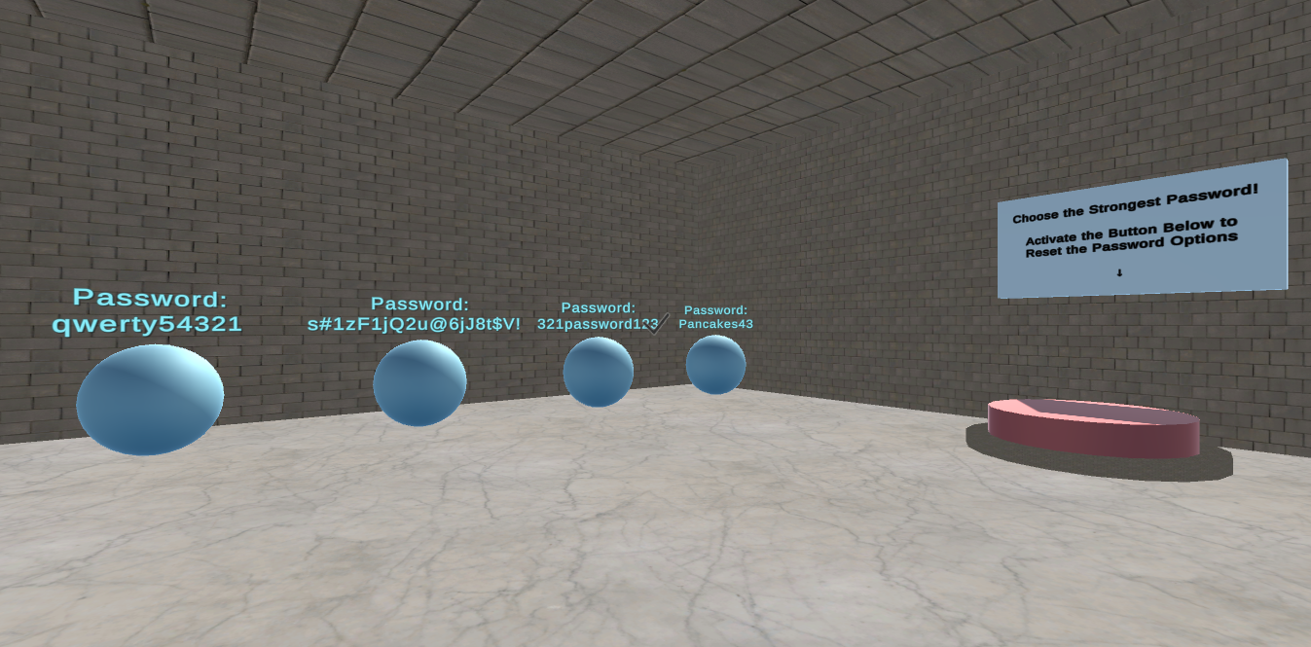

**Figure 1. The four password options presented for the player to choose from, along with the button to reset the spawns of the objects.**

The next area of the level will simulate the actual two-factor authentication process.

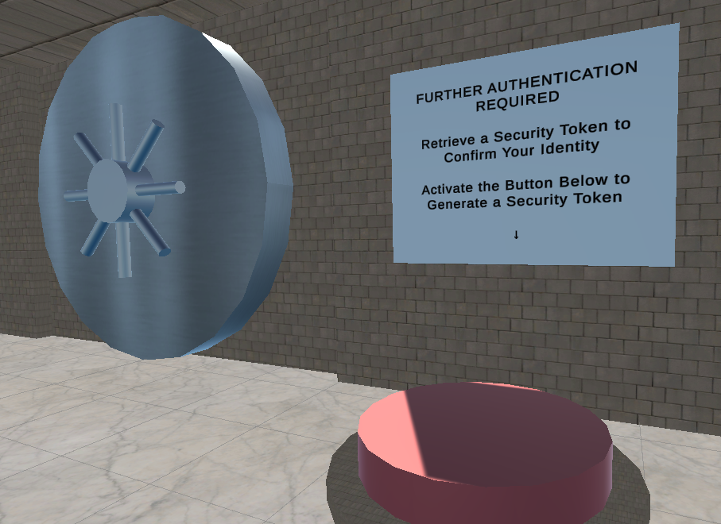

**Figure 2. A button press is used to simulate two-factor authentication requests.**

By pressing the button the player is made to simulate requesting a two-factor authentication code such as clicking the sign-in button on a website or game. This causes the code (security token) to spawn randomly in either one of two possible spawn locations in the current area, emulating an email or text message authentication code. Money piles that are prone to player collision will act as obstacles and barricades along the path to collecting the security token.

After the player is able to generate and collect the security token, they can unlock the vault door to advance to the next and final area of the level. The final escape key will present itself in the middle of the room for the player to collect. The key can then open the final escape room door, leading the player to the end game room where they are congratulated for completing the game.

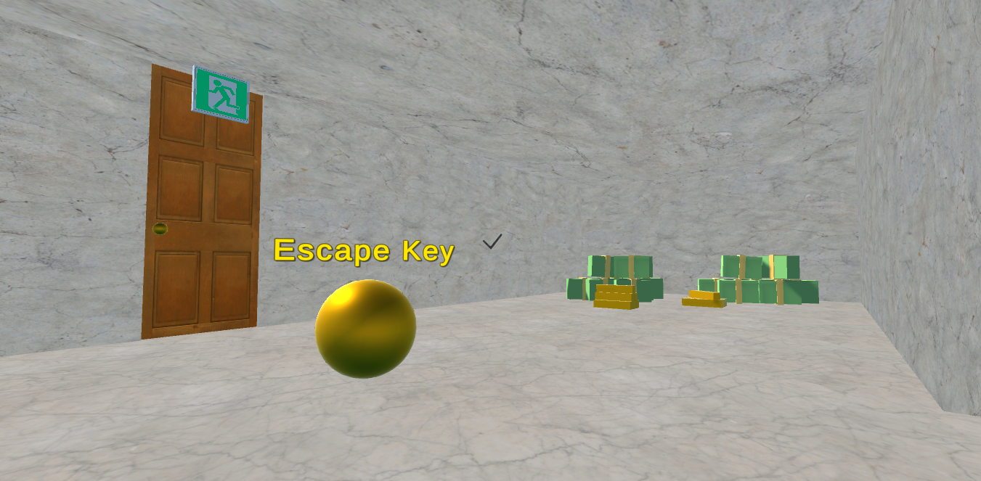

**Figure 3. The final escape key and escape door.**

The participant will be instructed on the methods of movement before the testing begins. The participant will then be able to use one method at a time in order to complete the objectives of picking up the items and moving through the doors to the next room. The participants will then play through the level a second time using the teleportation method in order to complete the game.

The first movement method tested will be the vertical head-tilt method. The vertical head-tilting method will allow participants to move forward by tilting their heads down to a certain degree and angle, which upon reaching will walk the player forward in the direction of their gaze.

The second method, the teleportation method will allow participants to teleport based on the direction in which they are looking towards. Participants can look around with their VR headsets and look at the designated green teleportation pads on the ground to teleport to that area. The teleportation pads are laid out in an efficient and fast path for the player to effectively move to the important areas within the level.

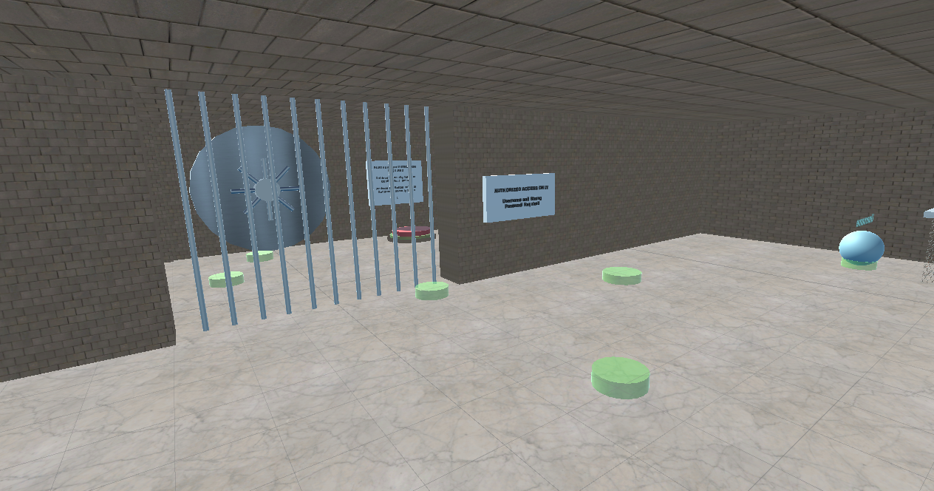

**Figure 3. A layout overview of various teleportation pads within the game.**

After the first playthrough, participants will be asked to repeat playing through the same level in the game using the teleportation method. Participants are then asked various questions after playing through the VR game twice with both movement methods. These questions pertain to the overall user experience while playing through the game, detailing what the user prefers or dislikes and their perceived challenges. Each question will be scored on a scale from 1 to 10.

Our User Experience Survey will ask the following questions:

**Q1**: How easy to use was the movement method?

*(1 = difficult, 10 = easy)*

**Q2**: How immersed were you in the game while using the movement method?

*(1 = not immersive, 10 = very immersive)*

**Q3**: How much did you enjoy using the movement method?

*(1 = unpleasant, 10 = enjoyable)*

**Q4**: Was the movement of the vertical head-tilt method too fast or slow?

*(1 = too slow, 5 = perfect, 10 = too fast)*

The mean score of all participants’ responses to the questions will be calculated and recorded across all four questions in the survey.

**Results**

The study aims to determine the best and most effective method of movement in a VR game between teleportation and vertical head-tilting. After conducting our study, the following results were gathered to gauge user experiences across both movement methods. The numbers reported below represent the mean user scores across all respective categories of the survey.

|  | **Teleportation** | **Vertical head-tilting** |
| --- | --- | --- |
| Ease of use  (1 = difficult,  10 = easy) | *8.75* | *8.42* |
| Immersion  (1 = not immersive,  10 = very immersive) | *8.42* | *8.92* |
| Enjoyment of the method  (1 = unpleasant,  10 = enjoyable) | *8.67* | *9.42* |
| Speed of vertical head-tilt  (1 = too slow,  5 = perfect,  10 = too fast) | *N/A* | *5.67* |

**Table 1. The mean scores reported across all collected User Experience Surveys.**

According to the surveys, the majority of users found that the head-tilt method was both easy to use and immersive. Some users found the head-tilt method both 10 out of 10 enjoyable and gave the method a 9 or 10 on ease of use. At least two users found teleportation to be easier to use than the head-tilt method, one of these teleport users also found the teleportation method to be less enjoyable than the head-tilt method.

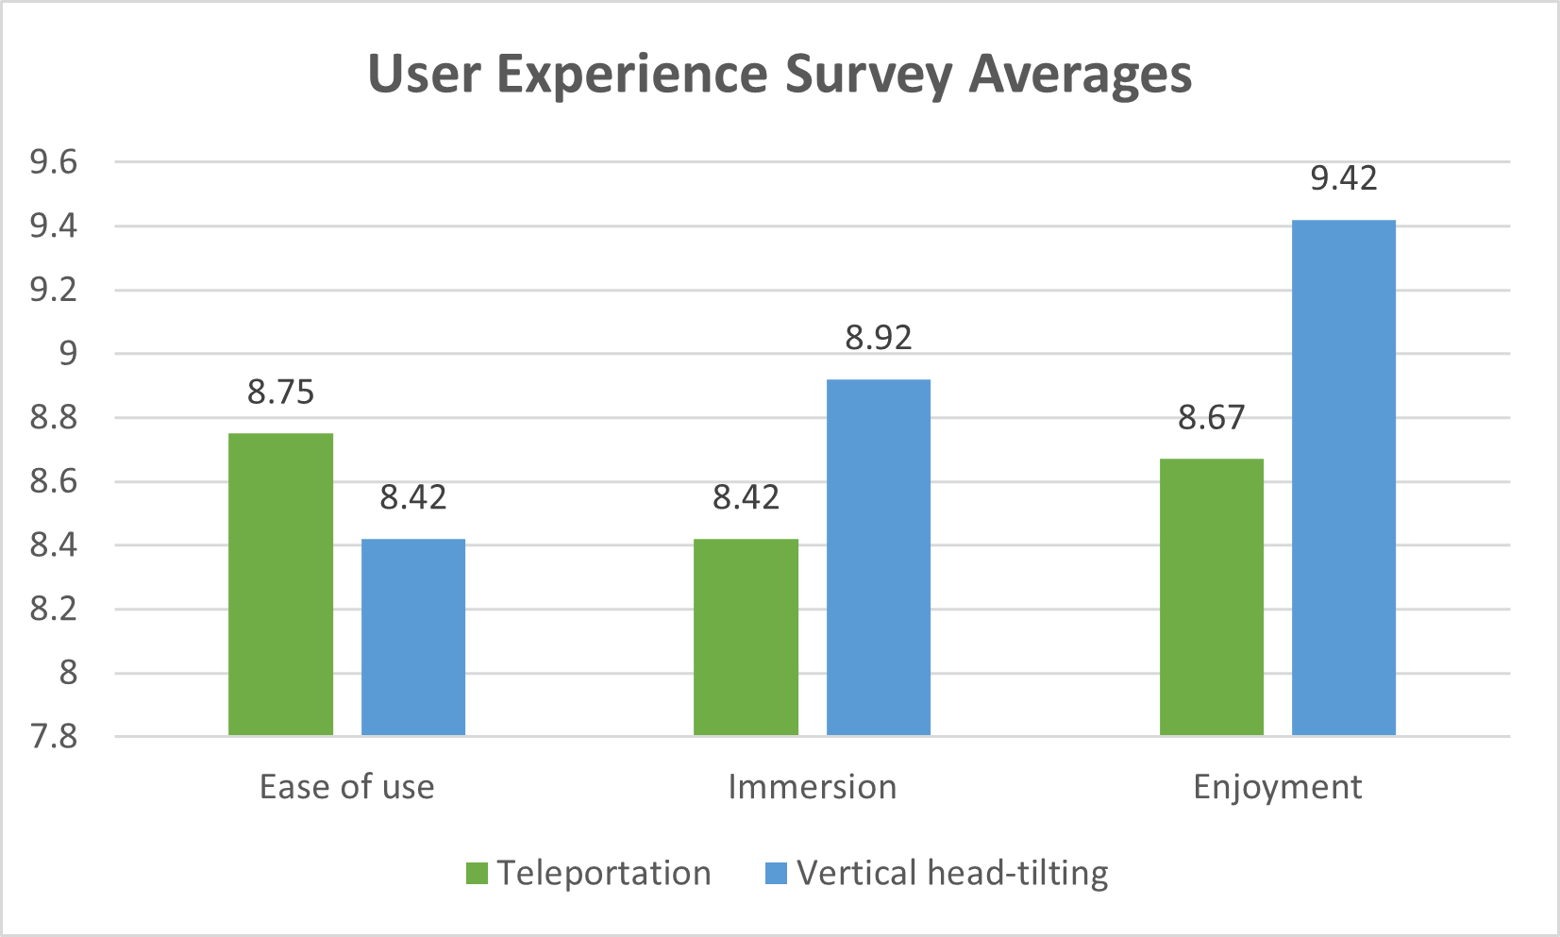

**Figure 3. A clustered column chart of the average scores retrieved from the User Experience Survey.**

All users had similar immersion scores, if each user’s scores are examined the difference in the immersion score is always less than 2. Multiple users reported their immersion in both methods were the same. When using the vertical head-tilting method, users agreed that the movement speed exhibited was near perfect. Users did not think that the set movement speed was too slow. Rather, three users thought that it was a little too fast with scores ranging from 6 to 6.5 range.

Across all surveys collected, no category in either the teleportation or vertical head-tilting methods exhibited any extreme low scores within the given 1 to 10 scale. Without taking the speed of vertical head-tilt scores into consideration, the lowest reported score was a 7. This score was expressed in an individual’s survey within the enjoyment category of the teleportation method. All other reported scores exist in the high 8 to 10 range across all categories.

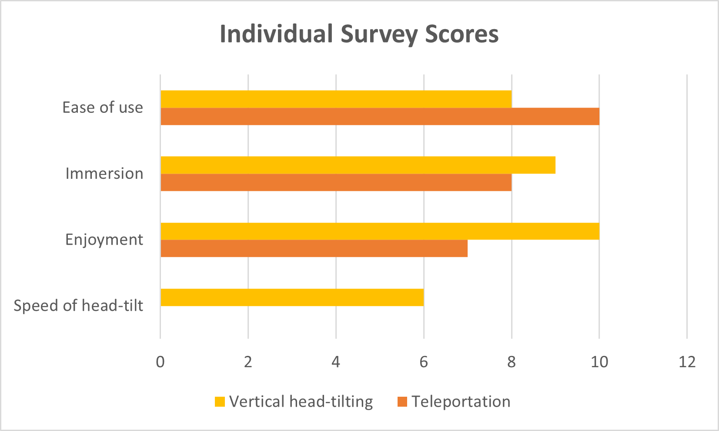

**Figure 4. A clustered bar chart of one individual User Experience Survey, containing scores reported in each respective category.**

**Evaluations**

The average scores calculated for each category (ease of use, immersion, and enjoyment) across both movement methods (teleportation and vertical head-tilting) will be compared and contrasted using graphs to find underlying preferences and effectiveness of the movement methods used. If the test receives overwhelming scores in favor of one method over the other, the question regarding the movement speed of the vertical head-tilting method will be considered.

In the graphs, the average scores do not indicate an overwhelming preference for ease of use or immersion. The scores for enjoyment indicated more users enjoyed the vertical head-tilt. The individual scores of 2 users rated teleportation as the highest rating of 10. Because none of the scores indicated that the speed of the vertical head tilting method was too fast or too slow this would indicate that there is no bias against the vertical head-tilting method.

If the scores of this question all indicate that the movement speed of vertical head-tiling is either too fast or too slow, this will indicate that the movement speed should be changed or made adjustable by the player and the test should be run again. Nonetheless, the results from the surveys displayed a mostly unanimous decision on the movement speed being nearly perfect, with a slight edge towards being a little too fast.If players were allowed to change their movement speed during the game it would be ideal.

Methods scoring higher in the ease of use and especially enjoyment categories will be more likely to be implemented as the final set movement method of the *VR Two-Factor Authentication Escape Room* game. Based on the results of the study, the reader may see that the score of the teleportation method (8.75) slightly edged out vertical head-tilting (8.42) in ease of use. However, when it comes to enjoyment, there is a larger disparity between both methods with a preference leaning towards vertical head-tilting (9.42) versus teleportation (8.67). Teleportation scored higher in ease of use, while the head tilting has a higher rate in the other two criteria.

**DISCUSSION**

Some limitations of the study involve limitations in the game. The game is very linear. Teleportation is limited by distance to limit accidental teleportations. Teleportation could have been more or less enjoyable if the players could teleport as far as they want or need to. Teleportation may have been more difficult for players due to there not being a visible indication of the center of the screen. According to other research papers, players should be allowed to manage their controls, in our case, allowing players to control the angle of activating the vertical head-tilt, with teleportation it would be good if the player is able to control the distance at which they can teleport as well as the size of the teleport pads to make them as easy as necessary to activate. Another possible point at which the research, and information gained from it, could be improved includes the lack of more robust level design. In the game that people played there was only one level. One level with a linear story progression might skew the results towards one movement method over another.

Discovering effective ways of navigating in VR can be more challenging using low-cost VR headsets as opposed to the more expensive alternatives. However, low-cost VR headsets, like the Google Cardboard, can bring in a more widely accessible audience who may not necessarily want to fully financially commit to pricier advanced headsets. The two movement methods explored in this paper intend to utilize the limited input methods presented in low-cost VR headsets to delve into the most user-friendly and effective option. The findings of our study do not show a strongly apparent preference discrepancy between ease of use, immersion, enjoyment, and overall effectiveness of both movement methods.

Choosing the desired main movement method within our *VR Two-Factor Authentication Escape Room* game requires further discussion of technical preferences, prioritizations, and overall vision of the game’s future going forward. Questions that might arise from such discussions will involve whether the enjoyment of a certain method will outweigh the benefits of a method being easier to use. The *VR Two-Factor Authentication Escape Room* serves as an educational game for practice and familiarization with the two-factor authentication process. With this notion in mind, another involves whether immersion and the player’s overall sense of presence within the VR environment are imperative in an educational setting.

` Every game can have a beautiful UX design, however, lacking the opportunity to level up in games is very common and can bring a negative user experience. Leveling up allows the user to show their progress or measure their progress. Without that, some users can't understand the point of the game and can become demotivated to keep playing. The game designers can try to implement this in future games they may design.The game’s designers believe the short couple of weeks wouldn't be enough to implement a game with leveling, and not just leveling, but leveling with rewards so that the user has something to look forward to achieving.

**CONCLUSION**

The motion method is essential to the success of a game and is a unique experience for the user through a virtual reality headset. Based on the research we conducted on two motion methods: teleport and vertical head-tilting. VR users can use different approaches and overall strategies for moving depending on the environment in which the user is navigating. After experiencing both motion and movement methods, users will evaluate which movement they feel more comfortable with and find enjoyable based on three criteria. The criteria are ease of use, immersion, and enjoyment. Gaming is a creative thing that will have many playstyles and players. Thus each player has their own style of play, as well as each movement method they are interested in that influences the player’s enjoyment.

With a good motion control method, users will be able to play the game in the way they are most comfortable with and bring the most enjoyment. As a designer, the user experience should be a priority in every major development. The users’ ability to move and stop at their signal increases the users’ likelihood to enjoy the game and play again. We noticed that having constraints, such as limiting when the vertical head-tilt method was activated, was a good addition to the game and made the game more playable. In the designing and programming phases, our group was able to find ways we could get feedback from possible users, and one that came to our mind was a survey. We would have our Google Cardboard VR set up and have the user answer some questions about ease of use and enjoyment for both movement methods. The result of these questions then helped us in evaluating our game and if any last-minute fixes were needed. In the end, we believe the results were similar to what we had imagined, but just like any development, there are limitations.

**REFERENCES**

| [1] | H. Cherni, N. Métayer, and N. Souliman, “Literature review of locomotion techniques in virtual reality,” *International Journal of Virtual Reality*, vol. 20, pp. 1–20, Mar. 2020, doi: 10.20870/IJVR.2020.20.1.3183. |
| --- | --- |
| [2] | Keil, J., Edler, D., O’Meara, D., Korte, A., & Dickmann, F. (2021, March 8). *Effects of virtual reality locomotion techniques on distance estimations*. MDPI. Retrieved July 26, 2022, from https://www.mdpi.com/2220-9964/10/3/150#cite. |
| [3] | L. D. Clark and S. L. Riggs, “Movement Strategies in Virtual Reality: The Influence of Effort Costs and Target Depth,” Proceedings of the Human Factors and Ergonomics Society Annual Meeting, vol. 64, no. 1, pp. 1600–1604, Dec. 2020, doi: 10.1177/1071181320641385. |
| [4] | W. Kim and S. Xiong, “User-defined walking-in-place gestures for VR locomotion,” *International Journal of Human-Computer Studies*, vol. 152, p. 102648, Aug. 2021, doi: 10.1016/j.ijhcs.2021.102648. |
| [5] | W. Powell, V. Powell, P. Brown, M. Cook, and J. Uddin, “Getting around in google cardboard – exploring navigation preferences with low-cost mobile VR,” Mar. 2016, pp. 5–8. doi: 10.1109/WEVR.2016.7859536. |
| [6] | Y. M. Kim, Y. Lee, I. Rhiu, and M. H. Yun, “Evaluation of locomotion methods in virtual reality navigation environments: An involuntary position shift and task performance,” *International Journal of Human-Computer Studies*, vol. 155, p. 102691, Nov. 2021, doi: 10.1016/j.ijhcs.2021.102691. |

**Contributions Report**

| **Name:** | **Percentage Score:** |
| --- | --- |
| Trieu Le | 45.00% |
| Derek Martin Wicoff | 40.00% |
| Mustafa Khalif Ahmed | 5.00% |
| Khang H II Le | 5.00% |
| Vamshi Nizampatnam | 5.00% |
| Fatima El Obeid | 0.00% |